LAB #02

Name: Ghazal Fatima

Roll no: 31
Program: Computer Science
Section: A
Submitted To : Sir Asad Majeed
Date : 11-10-2026

Task 1
Type and save the following programs in Visual Studio. Run these programs and observe their output.
Program 1
#include <iostream>\nusing namespace std;\nint main()\n{\n char letter;\n letter = 'A';\n cout << letter << '\\n';\n letter = 'B';\n cout << letter << '\\n';\n cin >> letter;\n return 0;\n}
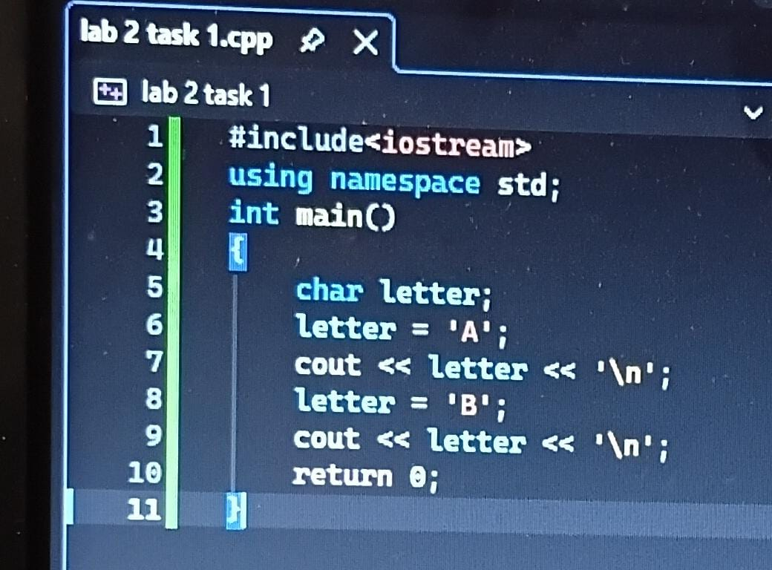
Program 2
#include <iostream>\nusing namespace std;\nint main()\n{\n char letter;\n letter = 65;\n cout << letter << '\\n';\n letter = 66;\n cout << letter << '\\n';\n cin >> letter;\n return 0;\n}

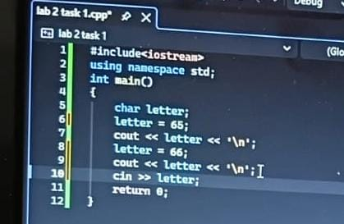

Task 2
Take two integers as input from the user, apply arithmetic operations on them (+, -, *, /), and print the results on the screen.
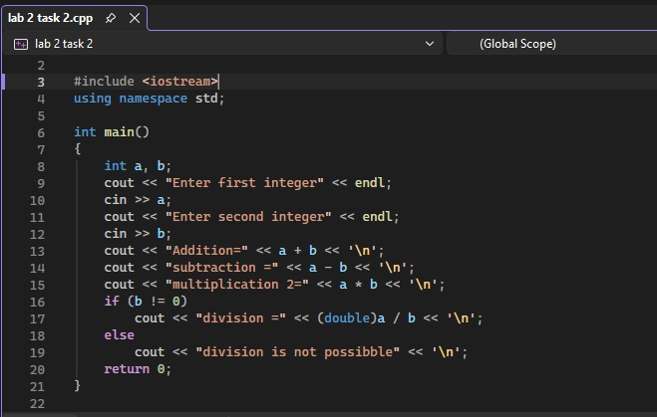

Task 3
Write the output of the following code.
#include <iostream>\nusing namespace std;\nint main()\n{\n int val1;\n int val2;\n int val3;\n cout << "Please enter your 3 numbers:";\n cin >> val1 >> val2 >> val3;\n cout << val1 << "\\n" << val2 << "\\n" << val3 << "\\n";\n cout << val3 << "\\n" << val2 << "\\n" << val1 << "\\n";\n system("PAUSE");\n return 0;\n}
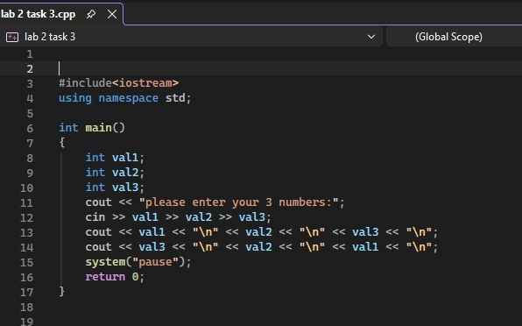

Task 4
Write a C++ program to calculate the distance between two points. Note: x1, y1, x2, and y2 are all double values.
Formula: d = √((x2 − x1)² + (y2 − y1)²)
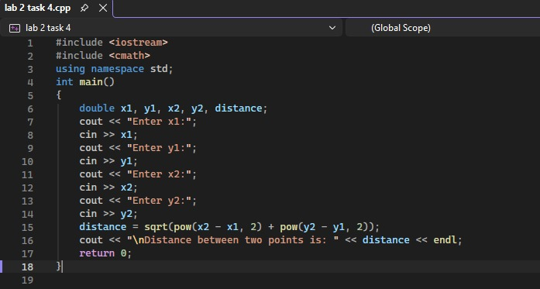

Task 5
1. Calculate the area of a circle (area = PI × r²).
2. Calculate the area of a rectangle (area = length × width).
3. Calculate the area of a triangle (area = base × height × 0.5).
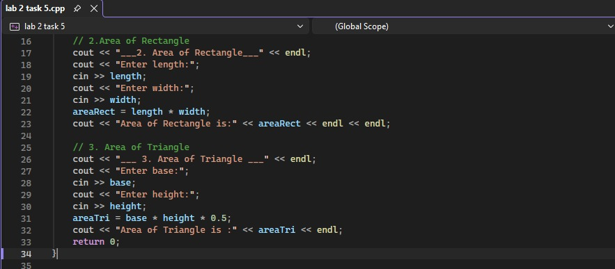

Task 6: Total Purchase
A customer in a store is purchasing five items. The prices are:
• Price of item 1 = $12.95\n• Price of item 2 = $24.95\n• Price of item 3 = $6.95\n• Price of item 4 = $14.95\n• Price of item 5 = $3.95
Write a program that holds the prices of the five items in five variables. Display each item’s price, the subtotal of the sale, the amount of sales tax, and the total. Assume the sales tax is 6%.
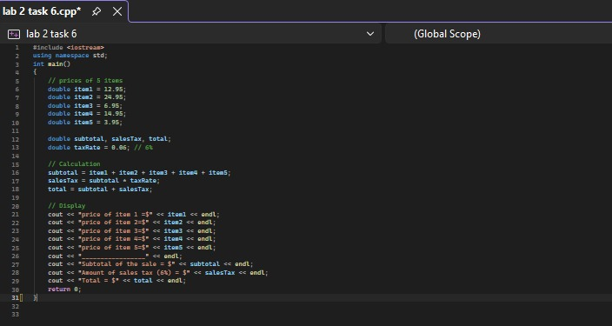

Bonus Task: Break Number
Write a program that inputs a five-digit integer, separates the integer into its individual digits, and prints the digits separated from one another by three spaces each.
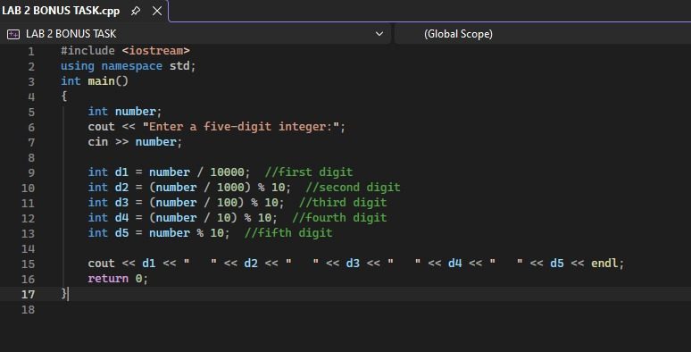

Home Tasks

Task 1: Exchange
Write a program that reads in two variables and swaps their values. For example, if var1 contains 10 and var2 contains 20, after the swap var1 contains 20 and var2 contains 10.
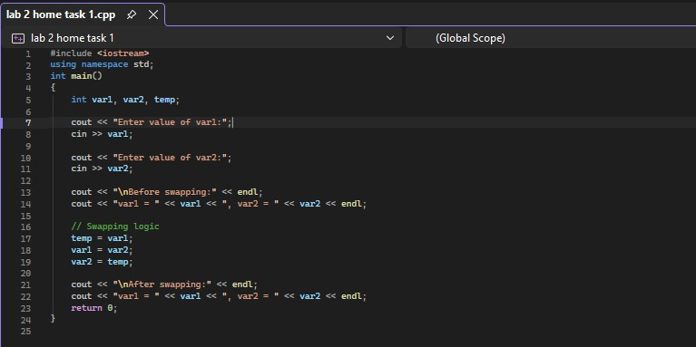

Task 2: Make Upper
Write a program that prompts the user to enter a lowercase alphabet (a, b, c, …, z) and displays the entered alphabet in uppercase (A, B, C, …, Z).
